

**AMERICAN INTERNATIONAL UNIVERSITY–BANGLADESH (AIUB)**

**FACULTY OF SCIENCE & TECHNOLOGY**

**DEPARTMENT OF PHYSICS**

**PHYSICS LAB 1**

**Summer 2020-2021**

**Section: D , Group: 1**

**LAB REPORT ON**

***To determine the time constant of an RC circuit***

**Supervised By**

**Bithi Paul**

**TABLE OF CONTENTS**

|  |  |
| --- | --- |
| **TOPICS** | ***Page no*.** |
| 1. **Title Page** | 1 |
| 1. **Table of Content** | 2 |
| 1. **Theory** | 3-4 |
| 1. **Apparatus** | 5 |
| 1. **Procedure** | 5 |
| 1. **Experimental Data** | 6 |
| 1. **Analysis and Calculation** | 7-10 |
| 1. **Result** | 10 |
| 1. **Discussion** | 11 |
| 1. **References** | 11 |

**Experiment name: To determine the time constant of an RC circuit**

1. **Theory**

Capacitors are used in timing circuit in many devices. The time that the dome lights inside a car stay on after turning off the cars ignition at night is one example of how a capacitor can be used to maintain the lighting long enough to remove the key and collect things before exiting. The values we use to characterize these kinds of circuits is given by the time constant defined as: τ = RC, where R is the circuit resistance and C is the capacitance. In this lab, we will observe the charging and discharging of a capacitor and determine the time constant of a RC circuit

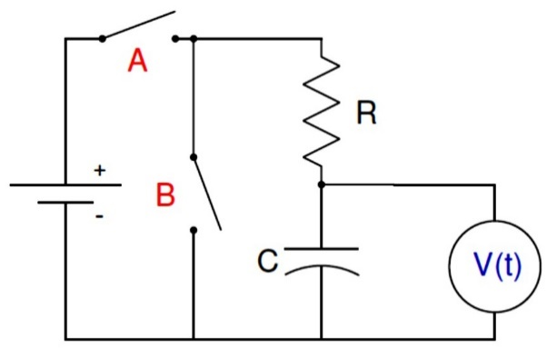

Figure 6.1: Circuit for RC charge-discharge measurement where V(t) is the potential difference across the capacitor as a function of time

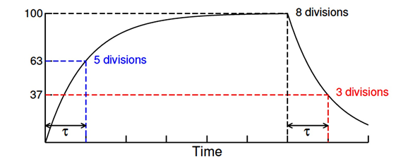

**V(t) / Vm**

Figure 6.2: Potential difference across a capacitor in an RC circuit as a function of time.

The time constant can be determine by observing the either the charging and discharging process

of the capacitor as the Fig. 6.2 shows. For the charging process, τ is the time for V(t) to reach 63% of its final value. For the discharging process, τ is the time for V(t) to fall 63% from its initial

value.

In the RC circuit in fig. 6.1, if at t = 0 switch A is closed (switch B remains open) charges will begin to build up in the capacitor. These charges do not accumulate within the capacitor instantaneously due to the resistance provided by the resistor. The potential difference across the capacitor for this process can be expressed as

**𝑽(t) = 𝑽m (𝟏 − 𝒆−t/𝝉)………….. (1)**

where Vm is the maximum potential difference across the capacitor.

After a sufficiently long time (much larger than time constant), if switch A is open while switch B is closed, the capacitor will discharge all of its accumulated charges. The potential difference across the capacitor can be expressed as

**𝑽(t) = 𝑽m 𝒆−t/****𝝉 …………...... (2)**

For charging, Eq. 1 can be written as,

$\ln\left[1-\frac{v\left(t\right)}{vm}\right]=\left(\frac{1}{τ }\right)t$**........... (3)**

Comparing Eq. 3 with y = mx and plotting a graph of " $\ln\left[1-\frac{v\left(t\right)}{vm}\right]$**𝒗s t**" we get the value of 𝜏

as 𝜏 = $-\frac{1}{m}$, where m is the slope of the graph.

On the other hand, for discharging, Eq. 2 can be written as,

$lnV\left(t\right)=\left(-\frac{1}{τ }\right)t+lnV_{m}……….$**(4)**

Comparing Eq. 4 with y = mx + c and plotting a graph of "**ln 𝑽(t) 𝒗s t** " we get the value of 𝜏 as

$$τ=-\frac{1}{m}$$

1. **Apparatus**

* Power supply
* Circuit board
* Resistor
* Capacitor
* Multi meter
* Stop watch
* Connecting wires

1. **Procedure**

* First of all, we have to construct an RC circuit on the circuit board as the circuit diagram shows
* After that we have to observe the charging of the capacitor and note the voltage differences across the capacitor with time by applying a sufficient voltage from the power supply.
* Then we have to disconnect the power supply from the circuit and observe the discharging of the capacitor with time. Finally, we have to note the voltage differences across the capacitor with time

1. **Experimental Data**

Table 6.1: Charging & Discharging of an RC circuit.

Maximum potential difference, Vm = ---------Volts

|  |  |  |  |  |  |
| --- | --- | --- | --- | --- | --- |
| **Time**  **(seconds)** | **Charging capacitor** | | **Discharging capacitor** | | |
| **V (t)**  **(Volts)** | $$ln\left[1-\frac{V\left(t\right)}{V_{m}}\right]$$ | **V (t)**  **(Volts)** | | $$lnV\left(t\right)$$ | |
| 0 | 0 | 0 | 6.8 | 1.92 | |
| 30 | 4.6 | -1.13 | 4.92 | 1.59 | |
| 60 | 5.02 | -1.34 | 3.94 | 1.37 | |
| 90 | 5.35 | -1.55 | 3.37 | 1.21 | |
| 120 | 5.61 | -1.74 | 2.90 | 1.06 | |
| 150 | 5.84 | -1.96 | 2.10 | 0.74 | |
| 180 | 6.03 | -2.18 | 1.73 | 0.55 | |
| 210 | 6.16 | -2.36 | 1.42 | 0.35 | |
| 240 | 6.27 | -2.55 | 1.19 | 0.17 | |
| 270 | 6.37 | -2.76 | 0.98 | -0.02 | |
| 300 | 6.48 | -3.06 | 0.83 | -0.19 | |
| 330 | 6.54 | -3.26 | 0.69 | -0.37 | |
| 360 | 6.60 | -3.53 | 0.58 | -0.54 | |
| 390 | 6.64 | -3.75 | 0.49 | -0.71 | |
| 420 | 6.64 | -3.75 | 0.41 | -0.89 | |
| 450 | 6.70 | -4.22 | 0.34 | -1.08 | |
| 480 | 6.72 | -4.44 | 0.30 | -1.20 | |
| 510 | 6.74 | -4.73 | 0.25 | -1.39 | |
| 540 | 6.75 | -4.91 | 0.21 | -1.56 | |
| 570 | 6.77 | -5.42 | 0.18 | -1.71 | |
| 600 | 6.78 | -5.83 | 0.16 | -1.83 | |
| 630 | 6.78 | -5.83 | 0.14 | -1.97 | |
| 660 | 6.79 | -6.52 | 0.12 | -2.12 | |
| 690 | 6.79 | -6.52 | 0.10 | -2.30 | |

1. **Analysis and Calculation**

**Graph-1:**

**Graph-2:**

**Graph-3:**

**Graph-4:**

**Calculations:**

**Theoretically:**

Time constant, 𝜏 = 𝑅𝐶 = 47 KΩ × 2200 μF = (47×103) × (2200×10-6)

= 103.4 Sec

**Experimentally:**

**While charging a capacitor:**

From the graph-3,

Slope, m = - 0.0084

Time constant, τ $= -\frac{1}{m}$

$=-\frac{1}{-0.006}$

= 119.05 Sec

**While discharging a capacitor:**

From the graph-4,

Slope, m = -0.006

Time constant, τ $=-\frac{1}{m}$

$=- \frac{1}{-0.006}$

= 166.67 Sec

**Error between theoretical and experimental time constant (while charging):**

Error = $\frac{119.05-103.4}{119.05}× 100\% = 13.15\%$

**Error between theoretical and experimental time constant (while discharging):**

Error = $\frac{166.67-103.4}{166.67}× 100\% = 37.96\%$

1. **Result**

Table 6.2: Values of time constant, τ.

|  |  |  |  |
| --- | --- | --- | --- |
| From the graphs | | Estimated Values of τ (=RC)  in seconds | Comments |
| Process | Values of τ in seconds | Theoretically, time constant is 103.4 seconds.  Experimentally, the value of time constant is 119.05 seconds while charging and 166.67 seconds while discharging the capacitor according to the graphs.  The difference between the time constants while charging and discharging is 47.62 seconds.  Error between theoretical and experimental time constant (while charging) is 13.15% and error between theoretical and experimental time constant (while discharging) is 37.96%. |
| Charging | 119.05 | 103.4 |
| Discharging | 166.67 |

1. **Discussion**

* From the experiment, it is necessary to see that the null point is not far away from the middle.
* It is also essential to see that none of the plugs in the resistance box R is loosed
* Special care should be taken to determine the diameter (d) of the wire very accurately.
* On reversing the current if the null point changes appreciably, the thermo-electric effect will be too large. The deflection of the galvanometer should be taken as the zero when looking for a null point.

1. **References**

For further understanding students may go through the following resources:

* **Fundamental of Physics (10th Edition)**: Capacitor (Chapter 25, page 717-721),

RC circuit (Chapter 27, page 788-791).

* Video Links:
* https://www.youtube.com/watch?v=f_MZNsEqyQw
* (4) 22 - Circuits - Time constant of an RC circuit - YouTube